Food Recommendation System

Using Euclidean Distance (KNN)

|  |  |
| --- | --- |
| Written by | Rahul Pidkalwar |
| Version | 0.1 |
| Date | 11/07/2021 |

Example-

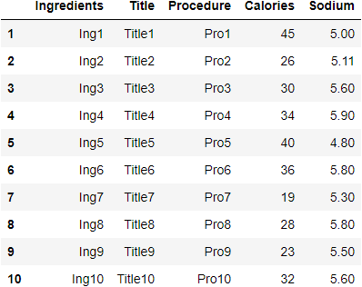

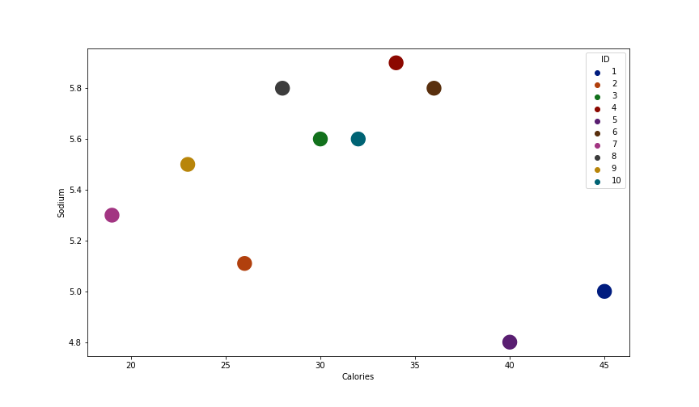

**For Diabetes**



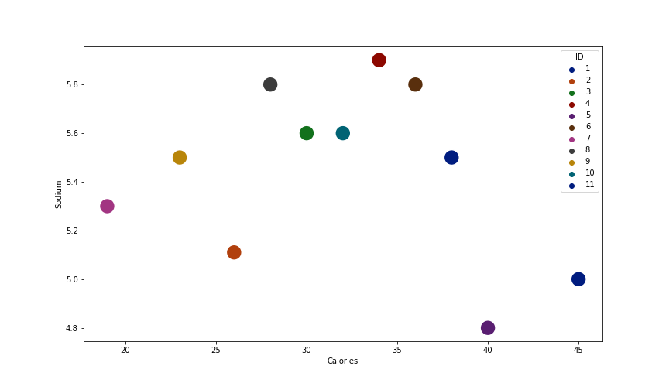

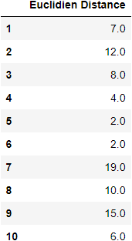

From above Euclidean distances, we can say that index = [5,6,4] (if we consider n=3)

has the closest match with the recommended features for diabetes.

User Inputs-

1. Height
2. Age
3. Weight
4. Gender
5. Activeness Level
6. Allergy
7. Disease (Hypertension / Hypotension / Diabetes)
8. Goal (Lose Weight / Maintain Weight / Gain Weight)
9. Type of Food (Veg / Non Veg)

# **Formula to calculate BMR-**

1. **BMR for Men**= 66.47 + (13.75 * weight [kg]) + (5.003 * size [cm]) − (6.755 * age [years])
2. **BMR for Women**= 655.1 + (9.563 * weight [kg]) + (1.85 * size [cm]) − (4.676 * age [years])

# **Activeness Level**

**Little/no exercise:**BMR * 1.2 = 1658.39*1.2 = 1990 Kcal/Day

**Light exercise:**BMR * 1.375 = 1658.39*1.375 = 2280 Kcal/Day

**Moderate exercise (3-5 days/wk):**BMR * 1.55 = 1658.39*1.55 = 2570.50 Kcal/Day

**Very active (6-7 days/wk):**BMR * 1.725 = 1658.39*1.725 =  2860.72 Kcal/Day

**Extra active (very active & physical job):**BMR * 1.9 = 3150.94 Kcal/Day

# **Meal Plan**

**Total BMR**

Breakfast Lunch Dinner

# Example-

**User Inputs-**

**Age** – 23 , **Weight** – 65 Kg, **Height** – 165cm, **Gender** – Male, **Health Issue**- Diabetes,

**Activeness Level** – Light, **(Gain Weight/ Maintain Weight/ Lose Weight)** - Maintain Weight

**Calculation of BMR-**

**BMR for Men**= 66.47 + (13.75 * weight [kg]) + (5.003 * size [cm]) − (6.755 * age [years])

**BMR for Men =** 1571.25 kcal

For Light Activity Level -

**Total BMR** = 2160.47 Kcal

**Breakfast**  **Lunch**  **Dinner**

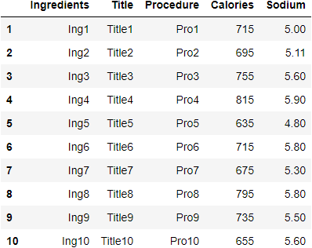

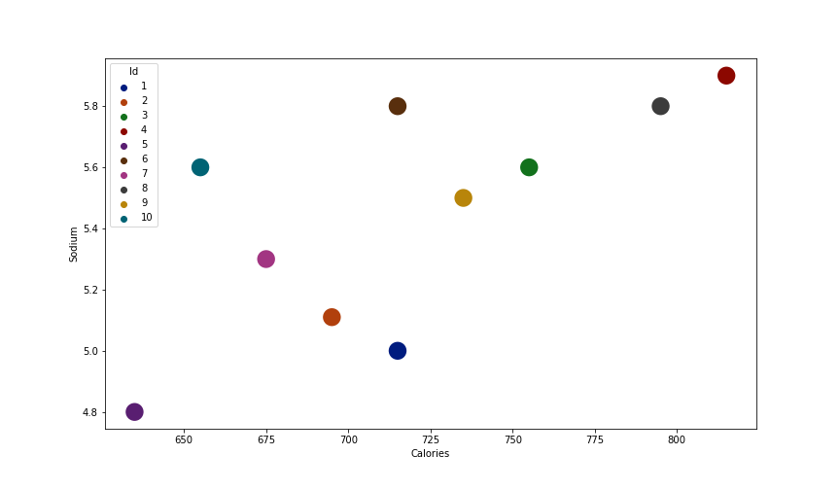

**For Breakfast-**

**Recommendation-**



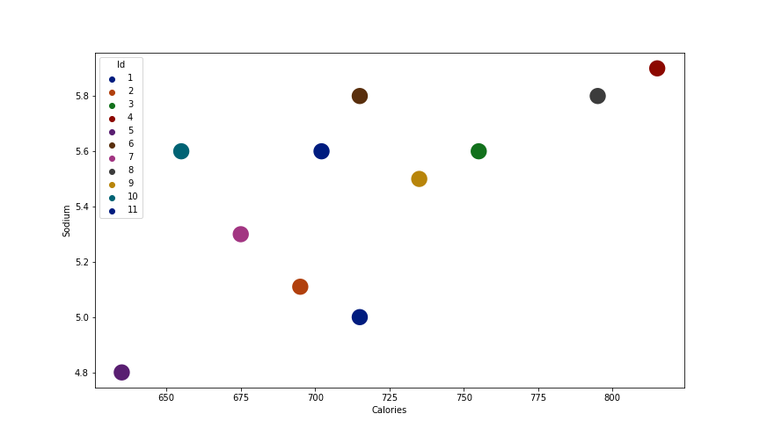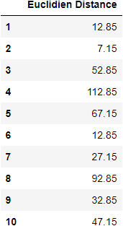

From above Euclidean distances, we can say that index = [2,1,6] (if we consider n=3)

has the closest match with the recommended features in Breakfast for diabetes.

**For Lunch-**

**Recommendation-**



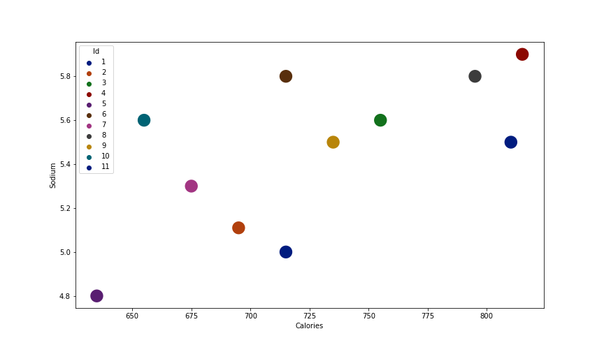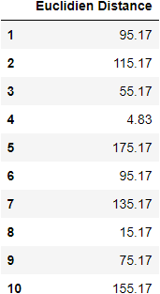

From above Euclidean distances, we can say that index = [4,8,3] (if we consider n=3)

has the closest match with the recommended features in Lunch for diabetes.

**For Dinner-**

**Recommendation-**



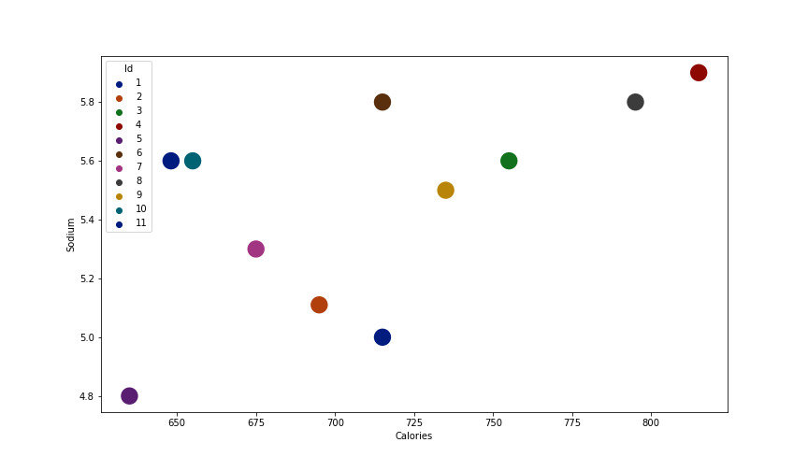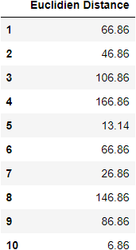

From above Euclidean distances, we can say that index = [10,5,7] (if we consider n=3)

has the closest match with the recommended features in Dinner for diabetes.

|  |  |  |  |  |  |  |  |
| --- | --- | --- | --- | --- | --- | --- | --- |
| **No** | **Disease** | **Saturated Fats** | **Unsaturated Fats** | **Sugar** | **Sodium** | **Carbs** | **Protein** |
| **1** | **Diabetes** | 7% * Cal.  [link](https://tinyurl.com/4rj2w6xm) | 20% * Cal.  [link](https://medlineplus.gov/ency/patientinstructions/000785.htm) | 30 gm  [link](https://www.diabetes.org.uk/guide-to-diabetes/enjoy-food/eating-with-diabetes/food-groups/sugar-and-diabetes) | 1.5 gm  [link](https://www.everydayhealth.com/type-2-diabetes/diet/salt-bad-diabetics) | 45% * Cal.  [link](https://www.medicalnewstoday.com/articles/how-many-carbs-per-day-for-a-diabetic#food-list) | 23% * Cal.  [link](https://www.verywellhealth.com/how-much-protein-should-a-person-with-diabetes-eat-2506615) |
| **2** | **Hypertension** | 7% * Cal.  [link](https://medlineplus.gov/ency/article/007483.htm#:~:text=Reduce%20saturated%20fat%20to%20no,as%20olive%20or%20canola%20oil.) | 20% * Cal.  [link](https://medlineplus.gov/ency/article/007483.htm#:~:text=Reduce%20saturated%20fat%20to%20no,as%20olive%20or%20canola%20oil.) | 30 gm  [link](https://www.healthline.com/health/high-blood-pressure-hypertension/foods-to-avoid#:~:text=One%20study%20in%20females%20with,teaspoons%2C%20or%2036%20grams%2C%20for) | 1.5 gm  [link](https://www.heart.org/en/health-topics/high-blood-pressure/changes-you-can-make-to-manage-high-blood-pressure/shaking-the-salt-habit-to-lower-high-blood-pressure#:~:text=The%20American%20Heart%20Association%20recommends,blood%20pressure%20and%20heart%20health.) | 50% * Cal.  [link](https://medlineplus.gov/ency/article/007483.htm) | 18% * Cal.  [link](https://medlineplus.gov/ency/article/007483.htm) |
| **3** | **Normal** | 10% * Cal.  [link](https://medlineplus.gov/ency/patientinstructions/000838.htm) | 17.5% * Cal.  [link](https://medlineplus.gov/ency/patientinstructions/000785.htm) | 33 gm  [link](euclidien.png) | 2.3 gm  [link](https://my.clevelandclinic.org/health/articles/11653-diabetes-tips-for-lowering-sodium#:~:text=Diabetes%3A%20Tips%20for%20Lowering%20Sodium&text=People%20with%20and%20without%20diabetes,to%202300%20mg%20per%20day.&text=The%20recommendation%20for%20sodium%20intake,sodium%20per%20day%20is%20recommended.) | 55% * Cal.  [link](https://www.mayoclinic.org/healthy-lifestyle/nutrition-and-healthy-eating/in-depth/carbohydrates/art-20045705) | 23% * Cal.  [link](https://www.verywellhealth.com/how-much-protein-should-a-person-with-diabetes-eat-2506615) |